NAME: Marc Brevoort

CONTACT No: 077 66 346 245

EMAIL ADDRESS: kleinebre@hotmail.com

REGION:  South East | Starter/Main/Dessert: Main
DISH TITLE:
Smoky Honey Chicken on a bed of Carrot purée
served with a Potato-and-gravy cupcake
and asparagus with orange Hollandaise sauce

INGREDIENTS / EQUIPMENT CONTESTANT WILL PROVIDE/UNUSUAL INGREDIENTS
Marc confirms to bring:
Lapsang Souchong tea (Twinings)
Kaffir Lime Leaves (Fresh)
Fresh ginger root
Fresh galangal root
Agar powder
Xanthan gum
Sweet soy sauce (ABC Kecap manis)
Chinese cleaver knife

DISH ELEMENTS
Honey Chicken
Carrot puree
Potato cupcake
Asparagus
Orange Hollandaise sauce

INGREDIENTS AND METHOD
INGREDIENTS

For the honey chicken:

(Note: many of these ingredients can be found in a Thai green curry kit and/or the asian/world foods section of your supermarket)

2-3 tablespoons sunflower oil
1 regular cooking onion (about 100 grams), peeled and diced small
2 cloves garlic, skinned and chopped small
2 teabags lapsang souchong tea (about 4 grams) (Marc will bring)
4-6 chicken “drum sticks” with bone (other leg pieces will work as well)
3-4 tablespoons acacia honey, (squeeze bottle, acacia) to taste
Acacia honey is slightly more tangy than “regular” honey. Either will do.

1-2 khaffir lime leaves, fresh (Marc will bring)
3 cm fresh galangal root, cut very small (Marc will bring)
(when using from frozen, about 1 heaped tablespoon freshly grated;
however for BBD this is not realistic)
3 cm fresh ginger root, cut very small (Marc will bring)
(when using from frozen, about 1 heaped tablespoon freshly grated;
however for BBD this is not realistic)
25 grams coconut cream (from a block)
(or ~125 cc liquid coconut cream)
6cm lemongrass (or 1 stalk, bottom crushed with a rolling pin)
(frozen will do, dried is not acceptable)
4 tbsp sweet soy sauce (ABC kecap manis) (Marc will bring)
Lemon juice to taste (juice of 1 lemon normally should suffice; having 2 or 3 available in total would be great)
1 tablespoon chinese oyster(-flavoured) sauce
Chili (fresh, powdered hot chili powder is acceptable) freshly ground black pepper, salt to taste; (note that the soy- and oyster sauces already contain salt so tasting before seasoning is essential).

Ingredients for the potato-and-gravy cupcake:

For the gravy:

1 white strong cooking onion (75 grams before peeling) peeled and diced small
7 grams soft brown sugar
11 grams balsamic vinegar
80 ml water
1 gram salt
1/2 oxo broth cube (vegetable/beef/chicken, to taste)
Note: I have been using veg cubes to allow the cupcake
to be made vegetarian
1/4 grams black pepper, freshly ground
5 grams worcestershire sauce (can be left out for veggie version)
2 grams lemon juice
20 grams lightly salted butter (president)
0.9 grams agar powder (Marc will bring)

For the potato base:

250 grams Maris Piper potatoes (Note: Marc is still performing taste tests to find the ideal variety of potato- Maris Piper is currently the potato of choice)
(~ 200 grams after peeling), peeled, diced into 1x1x1 cm cubes
10 grams fresh garlic, whole (3 cloves)
water for steaming
1 egg, split into yolk and white
1/3 nutmeg, finely grated from fresh
1/4 gr black pepper, to grate freshly
1/2 tbsp skimmed milk powder (absolutely NOT baby formula).

For the icing (Suspended for now- may be revived):

1 egg (white only – use leftover yolk for the orange Hollandaise sauce- or for the potato base if desired)
1/2 tbsp boiled green peas
few mint leaves, to taste (or a teaspoon of mint sauce?)
lemon juice, salt to taste to season
2 tbsp maltodextrin
1 cherry-sized or smaller tomato (skinned, soaked in red wine for 24 hours)

For the orange Hollandaise sauce:

Orange juice of half an orange
1 egg yolk
Fresh coriander leaf, chopped fine
60 grams butter (lurpak lightly salted), melted
Pinch of Xanthan gum- MARC WILL BRING
Black pepper to taste
Salt to taste
Lemon juice
For the carrot purée

150 g carrots, cleaned and diced, steamed along with the potatoes above;
Orange juice of half an orange
1 teaspoon caraway seed
pinch of aniseed powder

For the steamed asparagus
1 bunch green asparagus (7 spears- note: may not all be used)

Method:

Preparation:

Bring some water (about a litre) to boiling point.

For the smoky honey chicken:

- Cut the onion small
- Slowly sautee the onion in a few tablespoons of oil.
- Using a Chinese cleaver, cleave the ends off of the chicken pieces.
- De-bone the rest of the chicken pieces and reserve the bones.
- Cover the bones with hot water (1-2 cups), bring to a boil and simmer.
- Puncture the chicken pieces with a fork or other sharp pointy object.
- Using some more of the boiling hot water, prepare a strong, small cup of lapsang souchong tea (150 ml).
- When the onions are starting to brown, add the garlic.
- Brown the chicken for a while.
- Before the onion/garlic starts burning, add the tea.

- Add the coconut cream
- Add the lemon grass
- Add the lime leaf
- Add the small-chopped ginger root
- Add the small-chopped galangal root
- Add the sweet soy sauce
- Add the oyster sauce
- Add honey
- Add chicken bone broth
- Add lemon juice
- Season with salt, pepper
- Add chili (powder) to taste
- After a few minutes, taste and adjust sweet/salty/acid balance as needed with honey/salt/lemon juice.
- Stirring occasionally, simmer for 45 minutes, adding bone broth when the sauce thickens too much, to prevent it from burning
- Turn down the hob, set the sauce apart.
- Grill the chicken until golden brown (this step may be skipped; due to the use of lapsang tea we already have a smoky flavour).
- (When serving: Pour some of the reserved sauce over the chicken. If desired, the remaining sauce can be used as additional flavouring for the carrot puree or potato cupcake gravy)

Total prep time: 10 minutes
Cooking time: 50 minutes
Total cooking time: 1 hour

For the potato-and-gravy cupcake:

Preparing the gravy:

- Slowly sweat the onion in a bit of oil until transparent, soft, browned and fragarant. Make sure to take enough time for this! Protip: adding a pinch of bicarbonate of soda and the brown sugar will speed up the browning of the onions.
- While stirring, add the remaining ingredients- brown sugar (if not already added), vinegar, water* (*only to be added if the gravy gets too thick to be called a liquid), salt, oxo, black pepper, worcestershire sauce, lemon juice, butter and a thin dusting of agar powder.
- Transfer the gravy to a microwave safe freezing bag and quickly dip into cold water. After a few minutes, the gravy will be gelled
- After gelling, cut the gravy in 0.8x0.8cm cubes.

Preparing the potato base:

- Steam the potato cubes and garlic cloves for 15 minutes (or until the potato cubes are soft, whichever comes first). (Note: for the sake of saving time, carrots and asparagus of the other parts may be steamed along).
- Gently dry the steamed potato cubes with kitchen paper.
- Leave steaming for a bit
- Potato+steamed garlic cloves in a blender cup
- Add egg yolk to the blender cup
- Add nutmeg to the blender cup
- Add milk powder to the blender cup
- Add salt and pepper to the blender cup
- Add a teaspoon baking powder to the blender cup
- Blitz shortly. (we don't want a gloopy mess, but a puree which still has some structure left).
- Whip an egg white to peaks
- Transfer the potato mix to a bowl
- Add the reserved (gelled and cubed) gravy
- Mix potato and gravy cubes until fairly evenly distributed
- Fold in the egg whites
- Spoon the potato mixture into silicone cupcake moulds
- Bake for 20 minutes at gas mark 8-9 until risen, fairly dark brown and fragrant.

Preparing the icing (Note: untested- still under development):

Boil some peas, blitz along with the mint (or mint sauce). Make a royal icing using the maltodextrin (a low-sweetness sugar), salt, water, lemon juice and egg white. Optionally reserve a bit of this white mixture for further decorating. Combine the rest with the peas and mint, making sure the result is a light green icing.

To serve:

When using silicone casings, carefully remove the cupcakes from their casing (in case of a paper casing, it can be left on for decorative purposes and to add to the effect of the cupcake). Spread the icing onto the cupcake (or use a cake decorating back for that purpose). Using a syringe, add white decoration as desired. Finish it off with a “cherry” on top (a cherry-sized or smaller tomato, de-skinned, soaked in wine or beetroot juice for 24 hours- or optionally just half, deseeded). Briefly let the icing harden, but do serve before the cakes have cooled down so much that the gravy would set.

For the orange Hollandaise sauce:

Method:

- Whip together orange juice, egg yolk and greens.
- Slowly add the melted butter, starting with mere drops at a time, as if making a mayonnaise. Keep whipping. Continue until all the butter is incorporated into the sauce.
- As the orange is not very acidic and fat content may be low compared to a mayonnaise, the sauce may not thicken well; the pinch of Xanthan gum will correct this.
- Whisk vigorously after adding Xanthan. If the sauce does not set immediately, wait a bit for it to set. DO NOT add more xanthan gum; the sauce will thicken too much.
- Taste and season into a refreshing sweet/sour/salty sauce. Serve with steamed asparagus.

For the carrot purée:

- Clean and cube a ~150g carrot
- Steam until soft (about 15 minutes- test by pricking with a fork)
- Blitz thoroughly with the orange juice.
- Season with a pinch of ground aniseed and a teaspoon of caraway seed.

For the asparagus:

- 1. Cut off the base from the asparagus.
- 2. Peel off the skin
- 3. Steam (no longer than 7 minutes) Note: may not be needed at all.
- 4. Cover with a damp cloth until needed

Total Prep Time: 10 minutes Total Cooking Time: 45 minutes for chicken, 45 minutes for cupcake and sauce = 90 minutes

PLATING UP – Describe how the dish will appear on the plate
All dished must be presented on a plate/bowl

The honey chicken can be served on top of carrot puree to give a nice contrast between the brown of the chicken and the bright orange of the puree. The chicken would be plated up in the center of the plate.

The potato-and gravy cupcake would be on one end of the chicken, looking pretty much like a regular cupcake with light-green icing and a cherry on top- except it would have a quite savoury taste. (During the cook-off, there may not actually be enough time to also prepare icing, in which case it can be left out- this will make the presentation less dramatic but the dish will still be tasty).

The spring vegetables would be served on the other side, with a drizzle of orange Hollandaise sauce on top.

Serving suggestion:
(Asparagus would take the place of the peas, icing would probably be left out)

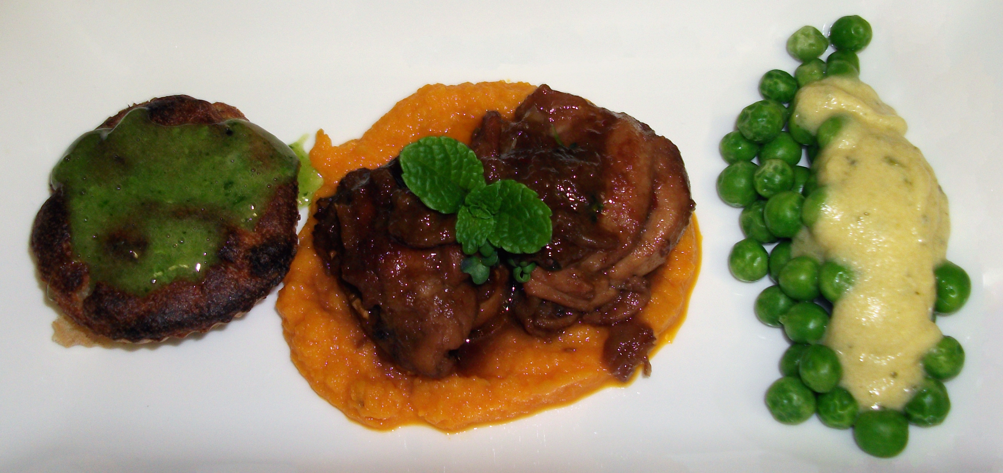

Equipment list:

Grater (for nutmeg)
Cleaver (MARC WILL BRING)
Knives
Cutting board wooden spoon,
Various teaspoons for tasting
Plenty of blender cups and temporary containers
Fork for pricking
Hand blender with both blending and whisk extensions,
Water boiler,
Steamer
Microwave safe (ziplock) freezing bags,
Pan suitable for stewing, cupcake moulds

TIME LINE
DO NOT FILL THIS SECTION IN – IT WILL BE COMPLETED BY THE FOOD TEAM AT A LATER DATE

TIME
PREP KITCHEN | CUPCAKE BASE-Potatoes-peeled and diced  Carrot puree- carrots peeled and diced  Asparagus – base cut off, peeled  Onion- skinned
DUMMY START | CHICKEN: Chop onion and garlic  CUPCAKE BASE: Onion chopped + Garlic crushed
120 | CHICKEN: Oil into pan- Slowly sauté onion, add garlic  CUPCAKE BASE: Steam potatoes, garlic for 15 minutes  CARROT PUREE: Steam carrot
110 | CHICKEN: Cleave the chicken in to small pieces and puncture chicken with a fork  CHICKEN: Add chicken to pan and brown for a while  CUPCAKE GRAVY: Oil and onions in pan
100 | CHICKEN: Add lapsang tea to pan  CUPCAKE GRAVY: Add ingredients + transfer to freezing bag- Leave for 2 minutes  CUPCAKE BASE: Into blender- Add egg yolk and season  CUPCAKE BASE: ADD GRAVY + MIX IN EGG WHITE
90 | CHICKEN: Add Coconut Cream, Lemon Grass, Lime Leaf, Ginger root, Galangal root, Soy Sauce and Oyster Sauce  CHICKEN: Add a mug of hot water to pan  CHICKEN: Taste and season- Add chilli powder, Honey and Lemon Juice
80 | CHICKEN: Add broth- Simmer for 45 MINUTES  CUPCAKE BASE: MIXTURE INTO MOULDS- BAKE FOR 20 MINUTES
70 | CARROT PUREE: Blitz carrot, orange, caraway and aniseed  CUPCAKE: Out of oven
60 | HOLLANDAISE: Chop herbs + whip ingredients
30 | CHICKEN: Remove chicken from pan and grill
25
20
15
10
5
PLATE UP

Note regarding time line: the cupcakes must be in the oven 30 minutes before the dish is plated up.

