

PLEASE INFORM PRODUCTION IF YOU ARE BRINGING REFRIDGERATED FOOD – YOU WILL NEED TO BRING IT TO THE STUDIO AS THE HOTEL ARE UNABLE ACCOMMODATE IT IN THEIR FRIDGE

PLEASE LABEL YOUR FOOD CLEARLY

TRAVEL ITINERARY- Marc Brevoort

Monday 28th February
Journey: Theale to Paddington (then on to Waterloo)
Ticket details: Pick up from ticket Machine at Theale Station
Ticket Collection Reference: R8NB9RJK

Please allow enough time to collect your tickets at the Station.

To collect your tickets from a self-service ticket machine:

1. Insert a valid debit/credit card
Please note your credit/ debit card is used for identification only, it will not be charged
2. Key in your unique Collection Reference Number.
3. Your ticket(s) will then be dispensed. Do not remove tickets from the machine until all tickets have been issued and the main screen informs you that the transaction is complete.

Both outbound and return train tickets will be dispensed at the machine (please double check none are left behind). Your outbound ticket will include your underground journey to Waterloo

Train departs Theale 19:06

Train arrives London Paddington 19:54

Paddington – Waterloo - Hotel

Take the southbound Bakerloo Line train 9 stops to

Exit out of Waterloo Main entrance and cross York Road, walk down Concert Hall Approach, then left along Belvedere road, continue past the London Eye and Chicheley Street, its on the right hand side

Premier Inn County Hall, Belvedere Rd, Greater London SE1 7PB: 0871 527 8648
Your Hotel Reservation number is: AKTR700917

Tuesday 1st March

You will be collected from the hotel between 10am-10:15am by one of the team at the car pick up point. Please be ready in the hotel lobby for your collection otherwise this could delay the filming of the show.

Breakfast has been paid for at the hotel

Please ensure you have checked out of your hotel and take all your belongings as you will not return to the hotel after the Studio

Your call time at the Studio is 10:30am

Return Train

Train departs London Paddington 20:00

Train departs Reading 20:41

Train arrives Lewes 20:50

Premier Inn County Hall, Belvedere Rd, Greater London SE1 7PB: 0871 527 8648
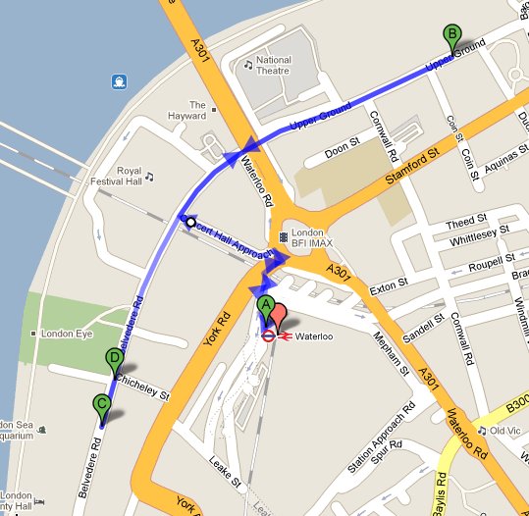
Map Key
A = Waterloo Main Station exit (other exits are found on York road and Waterloo Road)
B = ITV Studios (please bring any refrigerated food here before you get to your Hotel)
C = Premier Inn
D = Car Pick up point in the morning

General Information:
- Upon arrival to London if you have any food that needs refrigerating please bring it directly to the studios. Either a member of the production or security will put it in a fridge
If possible please let Rhiannon or Conor know in advance if you will need the fridge.

- On your studio day: please check out of your hotel before leaving for the studio and take all luggage with you, we will have an area for you to put your luggage at the studio.

- A car has been arranged to collect all contributors to from the Hotel – please do not attempt to make your own way to the studio. Please be ready for the car as any delays could hold up the entire studio schedule.
The car pick up point located on the map is at the end of the path leading up to the London Eye (this is due to us not being able to drive down the road of the hotel)

- We are able to provide you with a subsidy of £15 for your dinner for your overnight stay (will be given on your studio day) and lunch will be provided at the studio.

- No additional guests are allowed in the studio this is due to insurance purposes and a lack of space

- If you have any problems regarding this itinerary or at any stage of your journey please contact Rhiannon or Connor on: 02071574738 or 07932 797 215

Good Luck ! xx

