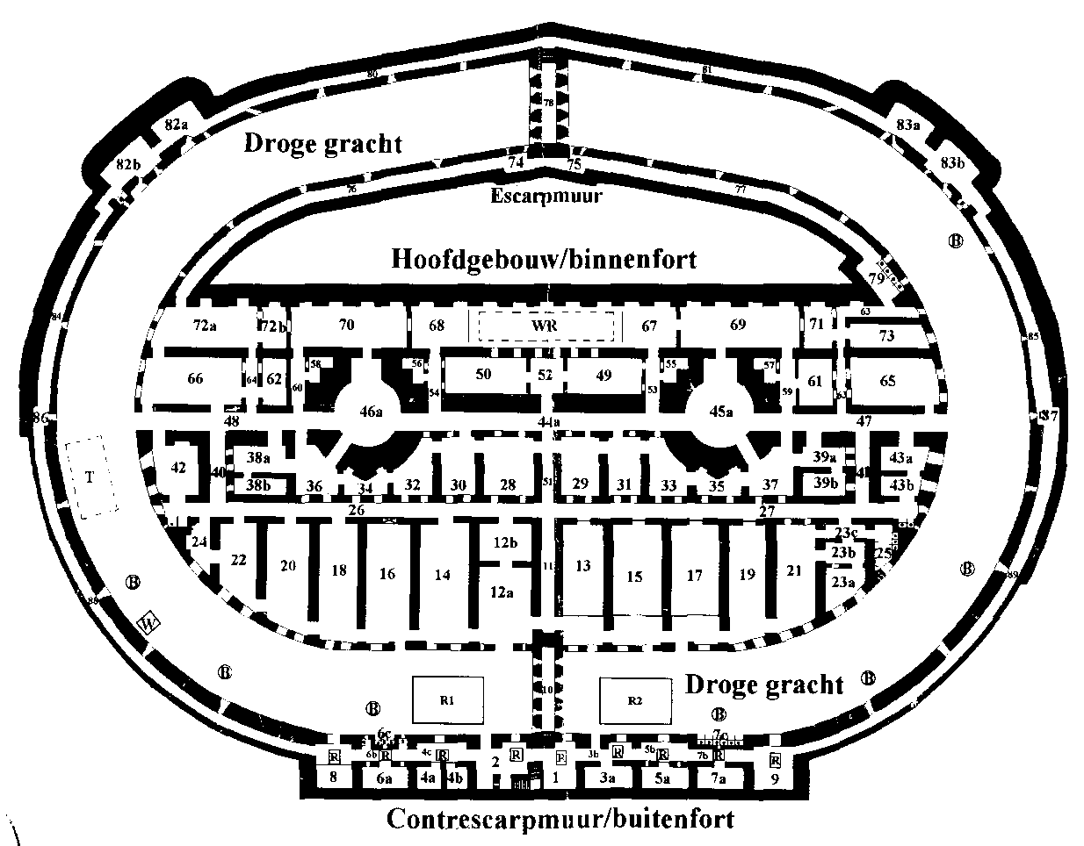
This fortress was built
around 1880 as part of
a military defence line.
It was never used.
The fortress is built inside
an island, most of it was
not visible from the water.
More info:
http://www.pampus.nl

In dutch, but babelfish
works well.

